Kick off meeting
Hellenic Center for Marine Research,
Heraklion, Crete, Greece
29-30 January 2014

The 2-day Kickoff meeting will be held at the Hellenic Center for Marine Research (HCMR), which is located in Gournes Pediados, 15 km east of the town of Heraklion, in the island of Crete, Greece.

TRANSPORTATION TO HCMR
Bus loading at 08:15 and Departure at 08:30
Transfers from/to the suggested hotels to/from the meeting site (HCMR) will be done with a bus, which will be waiting on the coastal road towards the sea from the hotels, near the roundabout with the fountain (see Photo 1).

There will be HCMR staff scientists in each hotel to help you find the bus (Mr Rigos, Mr Grigorakis and Mrs Cotou). Please be at the reception of your hotel no later than 08:15 to follow them to the bus.

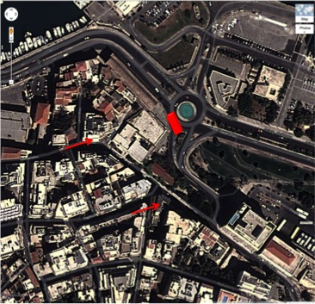

Photo 1. Map of the two hotels (red arrows) and the area that the bus will be waiting for you (red block) on the coastal road, next to the fountain.

If you miss the bus, the best way to get to HCMR is by taxi (20 min from the hotel). There is a taxi plaza at the central bus station, which is 5 min walking from the hotels (ask the reception). The HCMR is located next to the Creta Aquarium, which is very well known. Call me (Dinos Mylonas) at +30 6944 229754 if you have any problems.

Transportation back to the hotels will be by bus, departing outside the HCMR at the end of the working day (18:15).

MEALS
Coffee breaks will be offered by HCMR in the morning (11:00-11:30) and afternoon (15:30-17:00), outside the meeting rooms.

During both days, lunch will be offered at the restaurant of the Creta Aquarium (~13:00-14:00), which is next to the HCRM. The cost of the buffet (drinks included) is 12 euro per person per day, and should be paid by each participant at the restaurant.

Dinner will be offered by IRIDA S.A. (a partner of DIVERSIFY) during the evening of 29th (Wednesday at 20:00) at the restaurant Parasies (Παρασιές) in Heraklion, which is within 10 min walking distance from the hotels (Photo 2). Colleagues from HCMR who are staying at Hotel Marin Dream will lead you to the restaurant. Please be at the reception of your hotel no later than 19:45 to follow them to the restaurant.

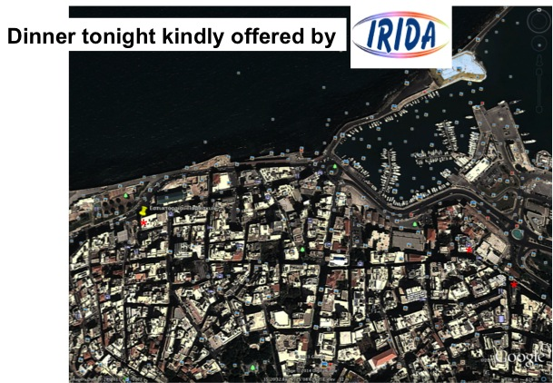
Photo 2. Map of the two hotels (asterisks) and the location of the restaurant “Parasies” (yellow pin and asterisk), were we will have dinner on Wednesday evening (29 January 2014).

AGENDA

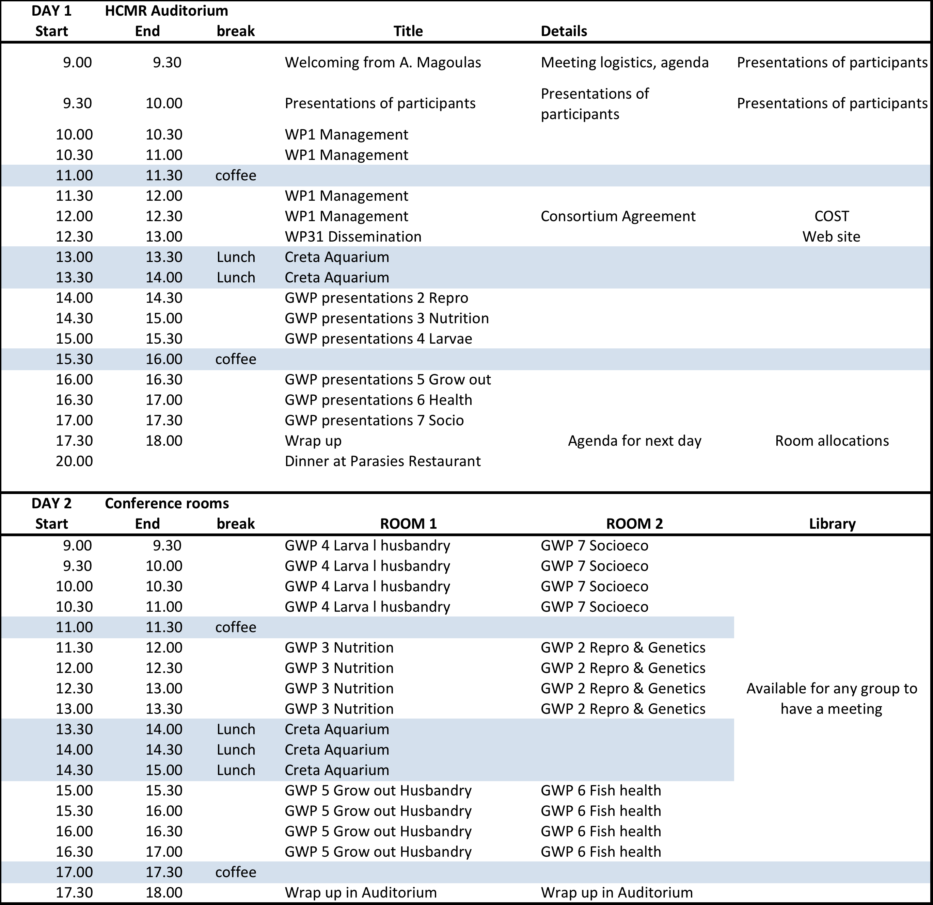

VISITS of the AQUALABS and the Creta Aquarium
During the second day, there will be time available if some partners are interested in visiting the AQUALABS of the HCMR. No formal arrangements have been made, but those who are interested can let me know and we will arrange 2-3 tours during the day (09:00 Dr. Pantelis Katharios; 11:30 Dr. Giannis Papadakis and 15:00 Dr. Constantinos Mylonas), to allow people to see the facilities when they are not involved in a Session.

The Creta Aquarium is open between 09:30 and 1700 and you can visit it at your own (8 euro per person), if you have available time.

INTERNET ACCESS
While at the HCMR, you can access the internet through wifi (ELKETHE-12)

TAXI
From Heraklion, you can access a taxi service at the central bus station, near your hotels. From the HCMR, you can get a taxi from in front of the Creta Aquarium. You can also call a taxi at +30 6937333730 (Mr Ximeris) and ask to be picked up at the central building (HCMR) of the THALASSOKOSMOS (the name of complex of the HCMR and the Creta Aquarium).

HOTELS
Transfer from the airport to the hotels can be done with taxis, which are available at the exit of the arrivals hall, at a cost of 10-15 euro.

Lato boutique Hotel
Epimenidou Str, Iraklion, Crete
Tel +30 2810-334955
http://www.lato.gr

Marin dream Hotel
Epimenidou Str, Iraklion, Crete
Tel +30 2810-300018
http://www.marinhotel.gr

USEFUL INFORMATION
Emergencies: | 112, 100
Ambulance Service: | 166
Fire Brigade : | 199
Police: | +30 2810 274010 (Station A) +30 2810 274190 (Station B)
Tourist Police: | +30 2810 274046
Hospital of Heraklion: | +30 2 810 368000-29, or 2810 392111
Airport : | +30 2810 228402
Heraklion Port Authority: | +30 2810 244912, 108
Tourist Information Centre of the National Tourism Organization
1 Ksanthoudidou St., | +30 2810 246100

