All material for dissemination must include a statement

The following statement should be included in all Dissemination material (press releases, interviews, web material, etc.)

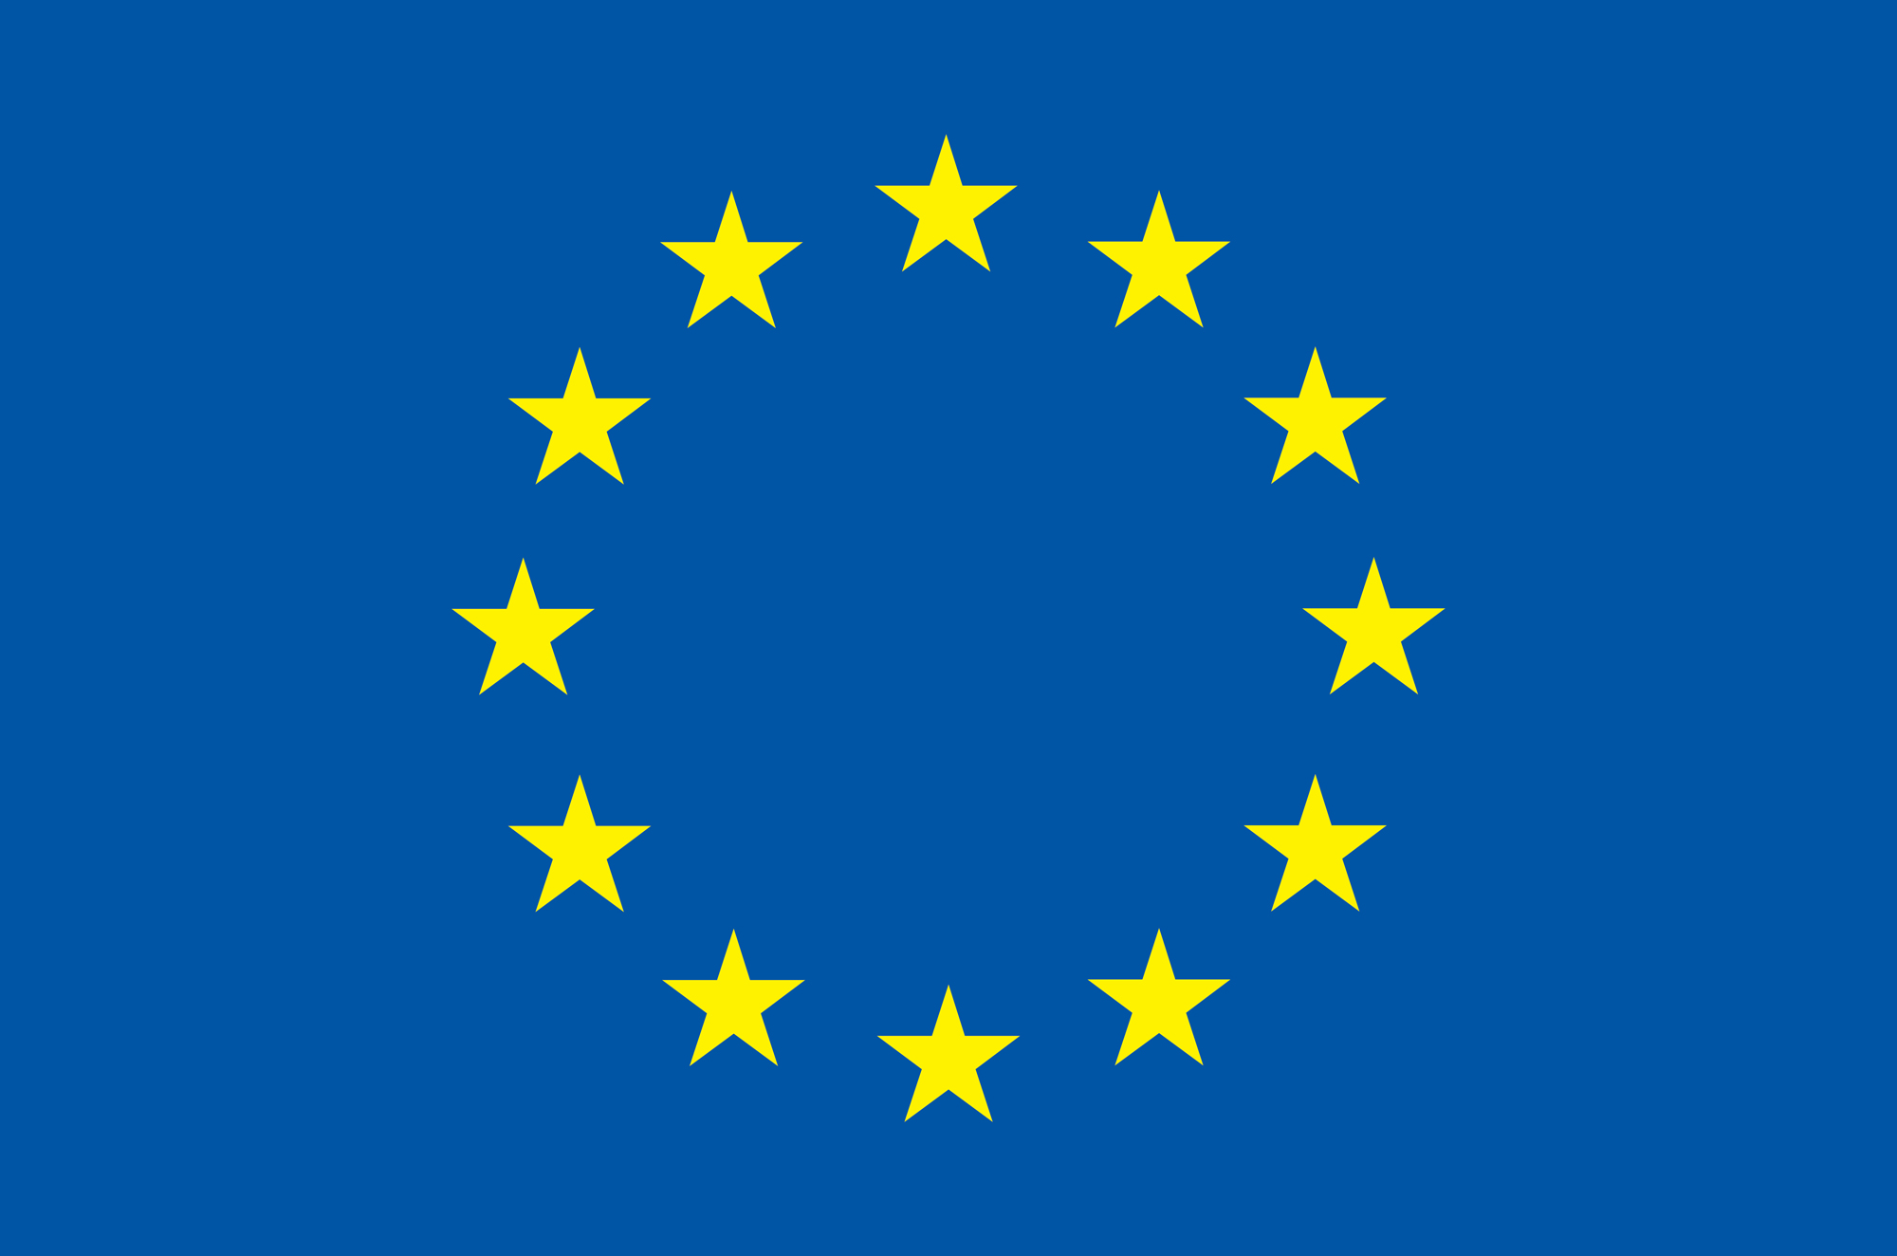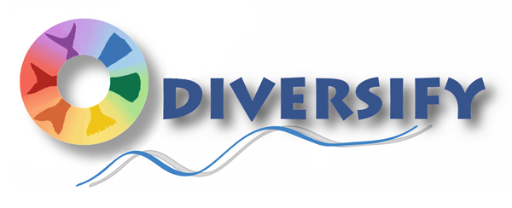
Co-funded by the Seventh Framework Programme
of the European Union
This 5-year-long project (2013-2018) has received funding from the European Union’s Seventh Framework Programme for research, technological development and demonstration (KBBE-2013-07 single stage, GA 603121, DIVERSIFY). The consortium includes 38 partners from 12 European countries –including 9 SMEs, 2 Large Enterprises, 5 professional associations and 1 Consumer NGO- and is coordinated by the Hellenic Center for Marine Research, Greece. Further information may be obtained from the project site at “www.diversifyfish.eu”.

The following statement should be included in all Scientific presentations (Abstracts, Posters, Oral presentations and scientific articles)

Co-funded by the Seventh Framework Programme
of the European Union
This project has received funding from the European Union’s Seventh Framework Programme for research, technological development and demonstration (KBBE-2013-07 single stage, GA 603121, DIVERSIFY).

In exceptional cases when there is a very strict word limit this is the minimum acceptable statement:

Funded by the European Union Project DIVERSIFY GA-603121

